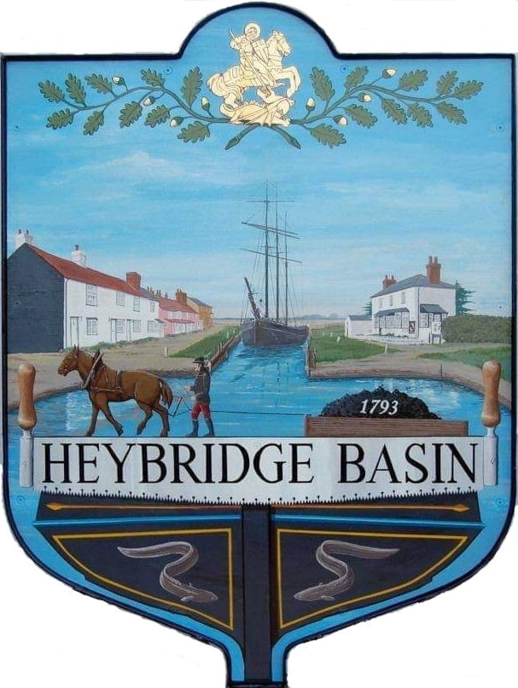

HEYBRIDGE BASIN PARISH COUNCIL

Minutes of the Full Council meeting of Heybridge Basin Parish Council held on Tuesday 15th October 2024 at 06:30pm, at St George’s Community Room.

PRESENT

In the Chair: M. Hodges (Chair) Absent: 0

Councillors: R. Bryson (Vice Chair) Apologies: 2
J. Sjollema
C. Swann Public: 4
C. Edmond

Officers: G. Lake – Clerk District Cllrs: 1

It was noted that this meeting was being recorded by the Clerk.

24/094 Chair’s Welcome.
The Chair opened the meeting, highlighting the strong attendance at the Timber Yard meeting and reporting that Essex Highways had re-lined the junctions since the last full council meeting.

24/095 To note apologies for absence.
Cllrs Hobden and Howat.

24/096 To receive Declarations of Interest in accordance with the Council’s Code of Conduct and with section 106 of the Local Government Finance Act 1992.
Cllr Edmond – Non-Pecuniary – Director of Essex Waterways; Cllr Swann – Non-Pecuniary – Relative provided quotations under Item 24/105

24/097 To sign as a correct record the minutes of the full council meeting held on 10th September 2024.
The Minutes as previously circulated were agreed as a correct record.

24/098 To sign as a correct record the minutes of the Extraordinary meeting held on 17th September 2024.
The Minutes as previously circulated were agreed as a correct record.

24/099 To receive a report from:
- District Councillors – A verbal report was provided by District Cllr N. Spenceley.
- County Councillor – A written report from Cllr Durham was circulated.

24/100 Finance.
- To approve
- Payment requests for September/October 2024
The Payment requests as previously circulated were approved.
- Receipts for September/October 2024
The receipts as previously circulated were approved.
- Accounts for the six months to 30th September 2024
The Accounts for the six months as previously circulated were approved.
- To consider the suggested alternative Bank Account for the Reserves and agree any action to be taken.
It was resolved for the Clerk to check if the Lloyds 32-day notice, 2.5% interest account was available to the Council and to apply if suitable.

24/101 External Audit for 2023-2024
  - To receive Section 3 – External Auditor Report and Certificate 2023/24 of the Annual Governance and Accountability Return (AGAR)
The External Auditor Report and Certificate for 2023/24 was received.

24/102 Memorial Policy
  - To receive the signed Licence Agreement from Essex Waterways.
The signed licence agreement was received.
  - To review, finalise and approve the Memorial Policy and application form and agree any actions.
The Memorial Policy and application form were reviewed, finalized, and approved.

24/103 Public Forum

Question: When can the public access the Minutes from the meetings?
Response from Council: Draft Minutes are always available on the website prior to the next meeting.

Further remarks: The member of public criticized the Parish Council, stating that it should be embarrassed regarding the handling of the Timber Yard planning application. Citing that the majority were opposed, yet the PC voted in favour. They argued that the Council had not represented the village adequately.

Chairs response: The Chair explained that the decision was made after a thorough review of the village survey responses, pros and cons to the application and residents views at the public consultation. Ultimately, the decision to approve the 13 houses with conditions was deemed the preferable option.

Clerk's response: The Clerk emphasized that the Parish Council cannot recommend refusal of a planning application based on personal opinions or preferences. Planning application decisions must be grounded in planning material considerations, as reflected in the Council’s comments.

Acknowledging the frustrations of objectors and recognising that it’s a controversial application, the Clerk stated that the Council had no basis for refusal due to a lack of supporting material considerations. The Parish Council is not a determining body, and as seen in other cases, the local district council (MDC) does not always align with the Parish Council’s recommendations. The Council can only make representations within the legal framework.

Clerk’s reminder:
- The Parish Council is not a determining body for planning applications.
- The Clerk’s inbox and telephone line are open for complaints and comments.
- Residents are encouraged to attend meetings.

24/104 Planning
- To consider any planning applications received after the publication of the agenda and to agree the action to be taken.
No planning applications were received.
- To discuss the land running to the north of the canal owned by Govey Homes and agree any action to be taken.
- It was resolved for the Clerk to contact Govey Homes regarding the potential purchase of land north of the canal and seek legal quotes if Govey Homes was interested.
- To receive an update from the Village Design Statement (VDS) Working Group and agree any action to be taken.
This item was deferred; a written report from Cllr Howat to be requested.
- To consider the need for a Neighbourhood Plan and agree any action to be taken.
The Clerk was tasked with contacting Maldon District Council to discuss the potential benefits of a
Neighbourhood Plan for Heybridge Basin.
24/105 Maintenance in the village
  - To consider the quotes received for cutting the hedges along Basin Road and agree any action to be taken.
It was resolved to contract HRS Marine Services to cut the hedges along Basin Road at a cost of £700. Cllr Swann abstained.
  - To consider the quote from HRS Marine Services to paint the bollards in front of the Noticeboard and agree any action to be taken.
It was resolved to accept the quote of £180.00 from HRS Marine Services. Cllr Swann abstained.
  - To receive an update from Cllr Swann regarding the trees outside St George’s Church and agree any action to be taken.
Cllr Swann reported that two dead branches on a tree outside St George’s Church needed removal. It was resolved for the Clerk to seek three quotes for the work.

24/106 Goal Posts/Netball Hoop
- To receive a verbal report from the Clerk and agree any action to be taken.
A verbal report was received from the Clerk.
It was resolved to return the Netball hoops at a cost of £55 plus 20% of the original order. The Council also resolved to purchase a Basketball hoop at a cost of £390.64.
- To receive the signed licence agreement from Maldon District Council and sign.
The signed licence agreement from Maldon District Council had not been received due to awaiting goal post size and orientation to be confirmed. It was resolved for the Clerk and Chair to sign the agreement upon receipt, subject to no changes.

24/107 Biodiversity
- To discuss the reports from the Essex Wildlife Trust Ranger and agree any action to be taken.
A proposal from Cllr Hodges was discussed:
- That the Parish Council (PC) instruct its Ground’s Maintenance contractor to implement a “No Mow May” action on all grassland maintained by the PC.
- That the PC contact the householders at the end of The Colliers to request that they leave a 2m strip of grass uncut along their fence line under the sea wall.
- That the Clerk write to the owner of Stebbens boatyard requesting that they remove the small number of old fibreglass/plastic tenders on their foreshore that are breaking up with bits being carried away on the tide.
- In addition to the planting plans already agreed in and around Daisy Meadow Car Park that a budget of £50 be set up for the purchase of wildflower seeds (from Boston Seeds) to be used along the fence line on the left-hand side of the new access road where there is a narrow strip of rough land.
- That the free bird box offer to residents be repeated. (No budget required).
It was resolved to accept all items included in Cllr Hodges proposal – Clerk to action.

24/108 Act of Remembrance
  - To finalise the plans for the Act of Remembrance and agree any action to be taken.
It was resolved to follow last year’s format for the Act of Remembrance, with the addition of Heybridge Primary School Choir performing. It was resolved for Cllr Edmond to purchase a wreath on behalf of the Council at a cost of £19.99.
The Chair would attend the Heybridge Parish Council service on Sunday 10th November and the Vice Chair would attend the Maldon service.

24/109 Daisy Meadow Car Park (DMCP)
- To receive an update from the Working Group and agree any action to be taken.
The Working Group provided an update on their review of car park operators that offer a pay-on-exit system.
It was resolved to continue with Smart Parking for 12 months while further exploring pay-on-exit options. The Clerk will inform Smart Parking of this decision.

The Working Group recommended continuing research into the installation of public toilets, including seeking cost estimates. This will enable the Council to make an informed decision on whether the project should proceed. It was resolved for the Council to accept the recommendation, with the Clerk uploading the project to the Contracts Finder website.

It was noted that planning permission would be required for the installation of EV chargers. The Clerk was tasked with contacting Maldon District Council to assess the likelihood of permission being granted, given the flood risk.

24/110 Clerk’s Report
- Parking charge scam – The Clerk issued a warning about fraudulent parking fine text messages, advising the public not to click on any links. It was emphasized that Smart Parking would never send text messages and only communicates via parking charge notice letters.
- Budget meeting availability – It was confirmed that most members are available for an Extraordinary General Meeting (EGM) on Monday 4th November, to discuss the Budget.
- On-Street parking petition – The Clerk reported that the petition regarding on-street parking had been submitted to the South Essex Parking Partnership and acknowledged. The process for review may take up to 12 months.
- Daisy Meadow Car Park Valuation – The Clerk informed the Council that a recent valuation of the car park had been completed, which could result in an increase in business rates.
- Website - The Clerk is currently seeking quotes to update the website to comply with accessibility regulations, with quotes ranging from £500 to £1,000. This will need to be considered during the upcoming Budget meeting.
- Clerk’s hours – October – The Clerk advised that her working hours would be reduced to two days during the school half-term, from 28th October to 4th November.

24/111 Correspondence
- To note correspondence received and agree any actions to be taken.
Correspondence was noted and responses were agreed.
It was resolved to donate £100.00 towards the village Christmas Tree and Keep Britain Tidy Campaign from the Donations Cost Code.
It was resolved to donate £100.00 to the Heybridge Primary School PTFA from the Chairs Allowance Cost Code.
It was resolved to donate £100.00 to Essex and Herts Air Ambulance from the Chairs Allowance Cost Code.

24/112 Newsletter
- To consider items to be included in the next Parish Council Newsletter and agree any action to be taken.
- Meeting venue change.
- CPR Training Interest
- Bird box offer
- Salt bags
- Act of Remembrance
- Diary of events

There being no further business the meeting closed at 08:16pm
Provisional Date of the next Council Meeting Tuesday 19th November 2024

Clerk Contact details: clerk@heybridgebasinpc.org.uk
Website: www.heybridgebasin-pc.gov.uk

